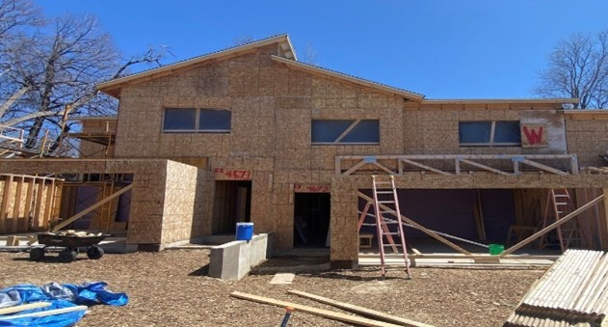
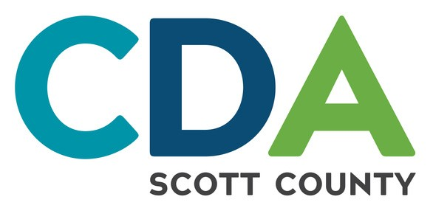

Dream of buying a home you can afford?
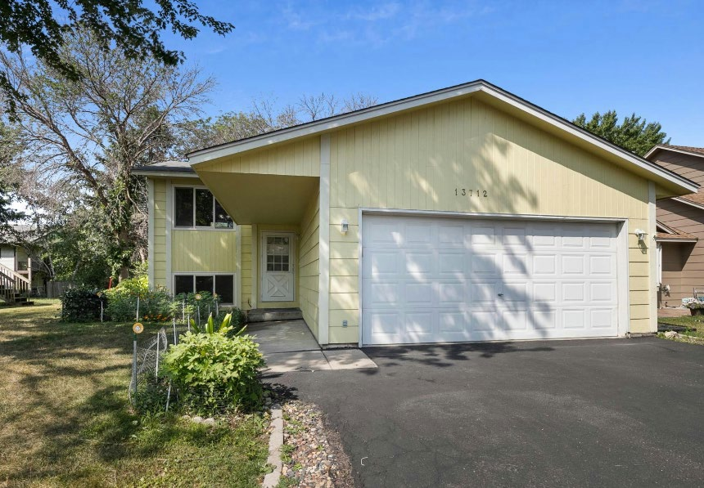
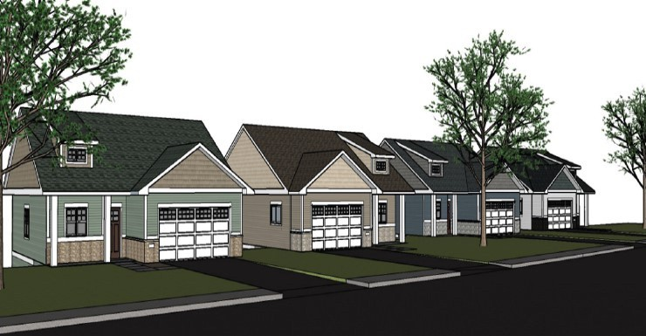
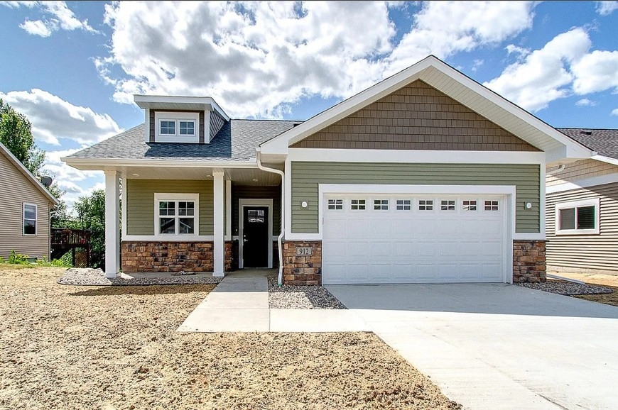
THE SCOTT COUNTY COMMUNITY LAND TRUST
has the following homes for sale...
Single Family homes - New Prague, MN
COMING SOON
=
$305,000

Single Family home – Savage, MN

Currently under renovation.
3 bedroom, 2 bath home in a convenient location near schools and parks.
More information will be available soon.

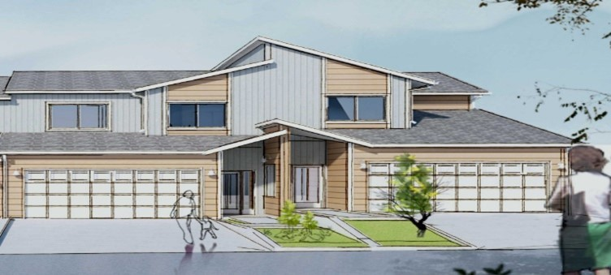
2000 square foot four-bedroom, 3 bath home in New Prague. Newly constructed with stylish finishes, an open layout, and a lovely neighborhood. These have visitability features for those with mobility impairments.
=
$165,00000-$200,0000

Townhomes homes - Prior Lake, MN
3-4 bedroom, 2 bath townhome with an attached two car garage. Available through a partnership with Habitat for Humanity. Prior Lake School District. You can start the intake process with Habitat and learn if you are eligible by going here: https://home.tchabitat.org/program-eligibility

* These homes are part of the Scott County Community Development Agency’s Land Trust Program. For eligibility requirements see back.

Scott County Community Land Trust Eligibility Requirements:

Community Land Trust homes follow the “shared equity” model. When you purchase the home, a significant public affordability investment has been applied which allows the CLT to sell these properties for below market value. In turn, when you sell the home, you will receive all the principal you paid, and 25% of the appreciation of the home.
Must be a first-time homebuyer.
(not owned a home or property for 3 years; manufactured/mobile homes excluded)
Must have taken a Homestretch homebuyer workshop no longer than 5 years before closing on the property. Online Framework class satisfies this requirement.
Must have completed a minimum of one pre-purchase counseling session with Scott County CDA homeownership specialist.
Must attend a free one-hour Community Land Trust Orientation class.
Mortgage payment must NOT exceed 30% of gross income (mortgage, interest, taxes, insurance, ground lease, repair/reserve fund, HOA dues if applicable).
Down payment/closing costs must be at least $1000 from buyers own funds.
Homebuyer must meet with a CLT lender and be deemed “pre-approved” for a CONVENTIONAL mortgage.
Household must match home size, i.e. 4 member households = 4 bedroom house. Household must meet income requirements dependent on the property type: 80% AMI or 60% AMI.
80% AMI income limits: $100,000/yr 60% AMI income limits: $75,000/yr

Preference for households in a Scott County CDA rental program. Must be in good standing. Preference for households where one head of household works or lives in Scott County.

UPCOMING EDUCATION & ORIENTATION

First-time Homebuyer Workshops 2024

TBD

To learn more or to register go to: https://scottcda.org/resource/first-time- homebuyers/
Community Land Trust Orientation 2023

TBD

Email clt@scottcda.org to register for upcoming sessions.

For more information:

Jessica Erickson, Community Development Manager (952) 641-5173
Email: clt@scottcda.org

